**VISUALIZATION OF DATA**

**APPLIED DATA SCIENCE  
ASSIGNMENT 1**

***Student Name:***

***Student ID:***

***Repo-Link:***

**Visualization 1: Multi-Line Plot**

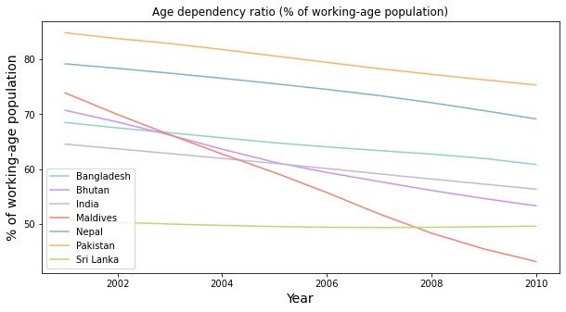

*Figure 1: Multi-Line Plot for Age dependency ratio for Asian countries from 2001 – 2010*

Figure 1 illustrates a multi-line plot depicting the Age dependency ratio for Asiancountries from 2001 to 2010. Pakistan seems to have the highest age dependency ratio % of the working-age population. A higher age dependency ratio indicates a larger proportion of the population that is dependent and, therefore, potentially puts a greater strain on the working-age population to support and provide for the dependents. Sri Lanka has the lowest ratio. Maldives shows a sharp decrease from 2001 to 2010.

**Visualization 2: Pie Chart**

From Figure 2 we can conclude that in 2001, at the start of the decade, Pakistan had a 17.2% of age dependency ratio. This was not an ideal situation for the demographic situation of the country since most of them are dependents. Nepal has the second highest percentage of age dependency ratio. Maldives had 15.0% and Sri Lanka the lowest at 10%.

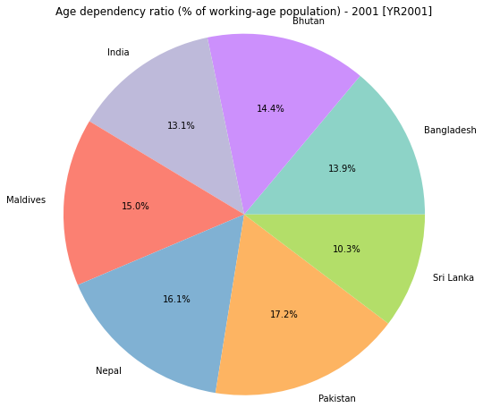

*Figure 2: Pie-Chart of Age dependency ratio of Asian Countries for the year 2001*

**Visualization 3: Bar Chart**

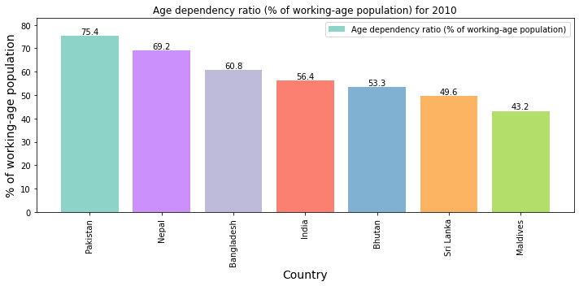

*Figure 3: Bar Chart of Age dependency ratio of Asian Countries for the year 2010*

By 2010, there is no change in the demographic situation of Pakistan as it stands first with the highest percentage of age dependency ratio at 75.4%. India and Bhutan stand in the middle at 56.3% and 53.3% respectively. A significant change is seen in Maldives as it has the lowest Age dependency ratio by 2010 replacing Sri Lanka which was previously the lowest.